Clinical Data Derivation Engine

Design Document – v0.1

System Architecture

CDDE automates the SDTM-to-ADaM derivation step of the clinical trial data pipeline. The system reads a YAML transformation specification and structured SDTM data (XPT format), dispatches five specialized AI agents to generate, verify, and audit derivation code, and outputs analysis-ready ADaM datasets with a complete audit trail.
CDDE is composed of
- A Vite + React frontend to manage the workflows and implement the HTIL steps.
- A Python FastAPI/FastMCP backend exposing REST and MCP APIs which is the core of the orchestrator.
- A database to persist workflows FSM and LTM.
CDDE can run locally as node.js and python processes or can be deployed in a Docker Compose infrastructure.
2 specifications are provided to test: simple_mock (AGE_GROUP, TREATMENT_DURATION, IS_ELDERLY, RISK_SCORE) and cdiscpilot01 (ADSL derivations for CDISC Pilot Study (Alzheimer's anti-dementia trial, used for ground truth comparison).
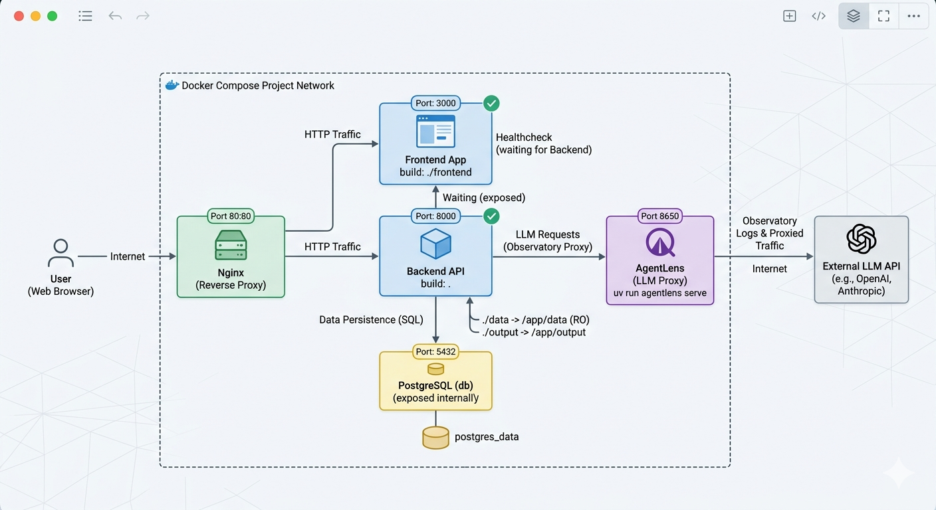

Study team flavor of the architecture

Key design choice: PydanticAI for typed agent abstractions (Agent[DepsType, OutputType]) + custom Python async orchestration for clinical workflow control. We evaluated CrewAI but rejected it: async_execution has known bugs (PR #2466), human_input is CLI-only, and structured output is bolted-on rather than native. PydanticAI passed all five orchestration patterns in prototype validation (parallel agents via asyncio.gather arrived within 0.01s).

Agent/module roles
Five agents mirror the real pharma workflow – each with a distinct cognitive task:
Agent | Output Type | Role | Why Separate?
Spec Interpreter | SpecInterpretation | Parse YAML spec, extract structured rules, flag ambiguities | Document understanding is not code generation
Derivation Coder | DerivationCode | Generate Python derivation functions from rules | Primary programmer (regulatory role)
QC Programmer | DerivationCode | Independently re-implement the same derivation | Must NOT see primary code – regulatory double programming (ICH E6)
Debugger | DebugAnalysis | Diagnose divergences between Coder and QC outputs | Debugging requires different reasoning than generation
Auditor | AuditSummary | Generate lineage reports and compliance checklists | Compliance review is independent from production
Double programming is the critical differentiator. In regulated pharma, FDA expects every derived variable to be independently verified by a second programmer. The QC agent has a different system prompt (encouraging alternative implementation strategies), isolated conversation history, and its output is compared programmatically – including an AST similarity check (>80% similarity flags “insufficient independence”). This is not testing; it is a regulatory requirement. All agents produce validated Pydantic output types. PydanticAI retries automatically on malformed responses.

Orchestration logic
Clinical derivation workflows cannot use off-the-shelf orchestration, and hardcoding one fixed workflow in Python would leave no room for per-study variation. CDDE uses a YAML-driven pipeline interpreter (engine/pipeline_interpreter.py): each pipeline is a YAML file in config/pipelines/ listing step definitions, and the interpreter topologically sorts the DAG of steps and dispatches each one through a typed executor from STEP_EXECUTOR_REGISTRY. Adding a new workflow variant is a YAML edit, not a code change.
Orchestration pipeline with sequential, fan-out/fan-in, concurrent/compare, HTIL patterns

Dependency handling
The DAG in domain/dag.py is an enhanced dependency graph – not just execution order, but lineage + computation + audit in every node:
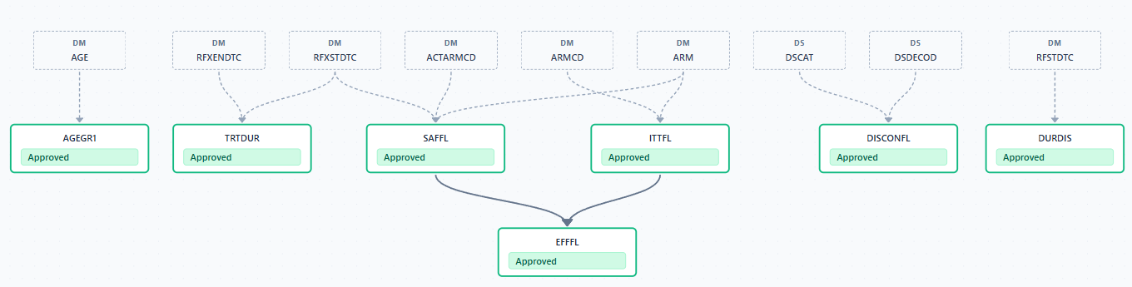
CDISC DAG

The engine reads source_columns from the spec and detects dependencies automatically: if EFFFL lists ITTFL and SAFFL (both derived), the DAG ensures they are computed first. networkx topological sort determines layer execution order. Cycles are detected and rejected loudly.
Each DAG node (domain/models.py: DAGNode) carries derivation rule, generated code, agent provenance, QC status, and human approval – making the graph the single source of truth for execution, lineage, and audit.

HITL design
CDDE deliberately favours depth over count for HITL gates — the clinical_derivation pipeline has one gate (human_review) but three distinct actions, each backed by a REST endpoint and a React dialog, each persisting to FeedbackRepository:
Action | Endpoint | What the reviewer does | What gets persisted
Approve with feedback | POST /workflows/{id}/approve | Opens ApprovalDialog, sees per-variable checkboxes defaulting to approved, unchecks any variable that needs rework, optionally adds a free-text note | One FeedbackRow per VariableDecision, action_taken = approved / rejected per row
Reject with reason | POST /workflows/{id}/reject | Opens RejectDialog, enters a mandatory reason | Workflow-level FeedbackRow, HUMAN_REJECTED audit event; FSM fails cleanly via WorkflowRejectedError (inherits from Exception, not BaseException)
Override code | POST /workflows/{id}/variables/{var}/override | Opens CodeEditorDialog, edits the approved pandas expression, provides a mandatory change reason | New code is executed on derived_df before state mutation; on success the DAG node, audit trail, and FeedbackRow are all committed in one transaction; on failure the original code is preserved and the dialog shows the 400 response inline
Why one deep gate, not four shallow ones: every HITL gate is a reviewer context switch. Clinical SMEs are expensive; their time is the bottleneck. A single rich dialog where the reviewer scans all variables at once, ticks or unticks in bulk, and confirms is cheaper to operate than four separate interruptions.

Traceability
Three complementary layers, each capturing a different concern:
Layer | Tool | What It Captures | Level
Trajectory tracing | AgentLens (OTel proxy) | Every LLM call, tool invocation, agent response – full agent trajectory | Agent
Orchestration logging | loguru | Workflow state transitions, DAG execution progress, HITL gate events | System
Functional audit trail | CDDE | Source-to-output lineage, agent provenance, human approvals, QC results | Business

The audit trail is append-only (no record deletion) and exports to JSON for programmatic analysis and HTML for presentation. Every derivation step produces an AuditRecord: timestamp, agent, input hash, output hash, rule applied, QC result, human approval. This satisfies 21 CFR Part 11 traceability requirements.

Memory design
Type | Storage | Scope | What is stored
Short-term (working) | PipelineContext in-memory + workflow_states table (JSON per step) | Single workflow | DAG, derived_df, step outputs, rejection flags, approval events. Persisted per step so runs can resume from the last checkpoint.
Long-term (validated) | patterns + feedback + qc_history tables | Cross-run | Approved derivation code, reviewer decisions (approve/reject/override) with reasons, QC verdict history with coder/QC approaches
The Coder agent has three PydanticAI LTM tools, each surfacing a distinct signal source so the LLM can weigh them by authority (human > debugger > prior agent). The system prompt instructs the coder to query them in order before generating code: query_feedback, query_qc_history, query_patterns
The save_patterns builtin runs after the human_review HITL gate and before audit.

Trade-offs
Decision | Trade-off | Our choice
Automation vs. control | Fully autonomous derivation vs. human gates at every step | One deep HITL gate in clinical mode (3 actions: approve-with-feedback / reject-with-reason / code override); 3 separate gates in enterprise mode for 21 CFR Part 11 — same engine, different pipeline YAML
LLM vs. rules | Pure LLM code generation vs. deterministic rule engine | Hybrid: LLM generates, deterministic comparator verifies, ground-truth comparison validates against the regulator’s reference, guards enforce constraints
Flexibility vs. compliance | Adaptable prompts vs. locked-down workflows | Pipelines are YAML — one engine, three ship-ready configs (express / clinical / enterprise), and per-study guard configs dial compliance independently
Pipeline in code vs. YAML | Hardcoded run_workflow() vs. YAML step definitions + executor registry | YAML. Adding a new workflow = new file in config/pipelines/, zero code changes. This is what lets us ship three pipelines from one engine.

Appendix

Data Security: Dual-Dataset Architecture
Agents never see patient data. The LLM receives schema metadata + a synthetic reference dataset (10-20 fake rows, same structure). Tools execute on real data locally and return only aggregates (null counts, value ranges, pass/fail) -- never raw patient rows. This is the correct production architecture, not a prototype shortcut: agents need data shape, not data content. The inspect_data tool is the security gate.

Limitations & Future Work
- Scope: ADSL (subject-level) only. BDS (longitudinal per-visit) derivations are the natural next phase.
- Spec format: YAML only. Production systems need PDF/Word spec parsing (SAP documents).
- No CDISC conformance validation: Integration with Pinnacle 21 or equivalent is a production requirement.
- Guard sophistication: Current guards are rule-based. A RAG-backed Sentinel with the full CDISC Implementation Guide is the evolution path.
- Software Architecture: for this solution, using PydanticAI and a custom orchestrator and AgentLens for observability was a good solution but at scale, migrating to the LangChain ecosystem could make more sense.
- System Architecture: authentication, user management, multi-tenancy was not implemented as this is usually an Enterprise infrastructure to be integrated with.

Production Path
CDDE was designed to easily be deployed on a researcher laptop to bigger deployment (team and enterprise) with minimal changes:
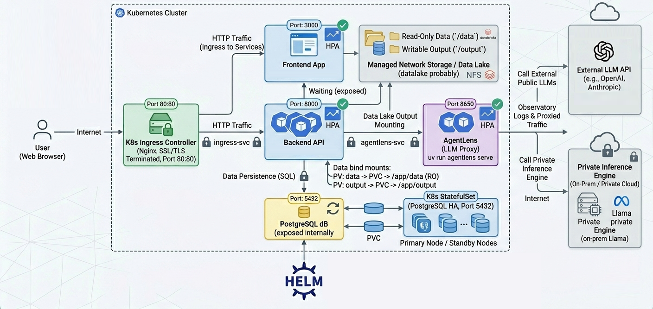
Example of Enterprise Architecture

Local | Team deployment | Enterprise deployment
SQLite | PostgreSQL (same SQLAlchemy async models) | PostgreSQL
Claude Code thru mailbox | Azure OpenAI in Sanofi VNet (private endpoint) | Azure OpenAI in Sanofi VNet (private endpoint)
Single-process dev server | Docker Compose (6 containers: nginx, frontend, backend, PostgreSQL, AgentLens, Grafana/Loki) | Kubernetes (same docker images, Helm chart, HPA auto-scaling)
Notes: for public cloud deployments (Azure, GCP, AWS), PaaS services such as Azure AppServices (Docker) or AKS (k8s), Azure Database for PostreSQL can be used to better manage operations and costs.

Comparison with Ground Truth

